Team Square Photos

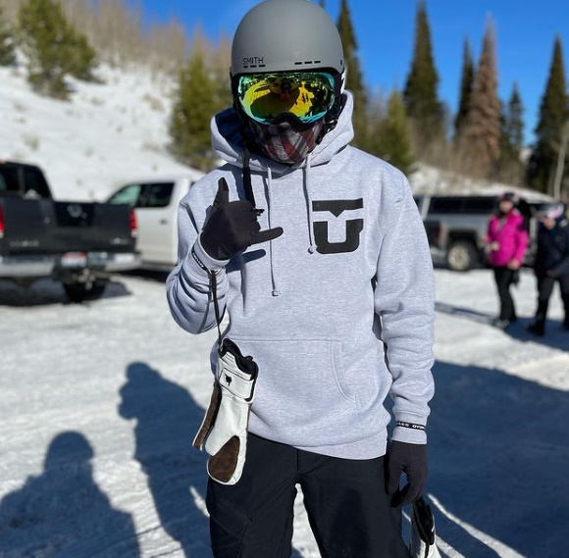

Craig Wright^^

Jeff Marsh